# CHAPTER 1:COVER PAGE

**CYBER SHUJAA PROGRAM-DATA AND AI**

**WEEK 8 ASSIGNMENT REPORT**

**THEME:** **CLASSIFICATION MODELS**

**STUDENT NAME: DOROTHY AWINO ONGONGA**

**STUDENT ID: CS-DA01-25075**

**DATE: 8TH-JULY-2025**

**JUPYTER NOTEBOOK LINK:** [**https://www.kaggle.com/code/awino614/classification-models**](https://www.kaggle.com/code/awino614/classification-models)

**GITHUB LINK:** [**https://github.com/Awino614/DATA-WRANGLING/tree/main**](https://github.com/Awino614/DATA-WRANGLING/tree/main)

**GOOGLE COLAB LINK:** [**https://colab.research.google.com/#fileId=https%3A//storage.googleapis.com/kaggle-colab-exported-notebooks/awino614/classification-models.1c5b01d5-2380-4846-a27e-969d9cb8abba.ipynb%3FX-Goog-Algorithm%3DGOOG4-RSA-SHA256%26X-Goog-Credential%3Dgcp-kaggle-com%2540kaggle-161607.iam.gserviceaccount.com/20250708/auto/storage/goog4_request%26X-Goog-Date%3D20250708T074448Z%26X-Goog-Expires%3D259200%26X-Goog-SignedHeaders%3Dhost%26X-Goog-Signature%**](https://colab.research.google.com/#fileId=https%3A//storage.googleapis.com/kaggle-colab-exported-notebooks/awino614/classification-models.1c5b01d5-2380-4846-a27e-969d9cb8abba.ipynb%3FX-Goog-Algorithm%3DGOOG4-RSA-SHA256%26X-Goog-Credential%3Dgcp-kaggle-com%2540kaggle-161607.iam.gserviceaccount.com/20250708/auto/storage/goog4_request%26X-Goog-Date%3D20250708T074448Z%26X-Goog-Expires%3D259200%26X-Goog-SignedHeaders%3Dhost%26X-Goog-Signature%)

CHAPTER2:INTRODUCTION

In the evolving field of artificial intelligence and data science, supervised machine learning plays a critical role in enabling systems to make intelligent predictions and decisions based on labeled data. One of the most fundamental tasks in supervised learning is **classification**, where the objective is to correctly categorize input data into predefined classes based on learned patterns.

This project focuses on applying various supervised classification algorithms to the **Wine dataset** from the Scikit-learn library. The Wine dataset is a well-known multi-class classification problem that involves predicting the **type of wine cultivar** based on 13 continuous physicochemical features such as alcohol content, malic acid, color intensity, and flavonoids. The dataset comprises three target classes, representing three different cultivars of wine.

The primary aim of this assignment is to:

* Understand the dataset structure through **exploratory data analysis (EDA)**
* Prepare the data by **scaling and splitting** it into training and testing sets
* Train and evaluate **six different classification models**:
  + Logistic Regression
  + Decision Tree
  + Random Forest
  + k-Nearest Neighbors (KNN)
  + Naive Bayes
  + Support Vector Machine (SVM)
* Assess and compare their performance using **standard evaluation metrics** including:
  + Accuracy Score
  + Precision, Recall, F1-Score (via Classification Report)
  + Confusion Matrix (with visual plots)

By comparing the models under the same conditions, we aim to determine which algorithm performs best in terms of classification accuracy and robustness, and analyze the reasons behind those differences. This exercise not only reinforces theoretical knowledge of machine learning algorithms but also builds practical experience in model selection, evaluation, and interpretation—key skills required for any aspiring data scientist or machine learning engineer.

This project is also intended to serve as a portfolio-ready notebook, demonstrating a complete machine learning workflow from data exploration to model evaluation and comparison.

CHAPTER 3:TASK COMPLETION GUIDE

### **1. Introduction**

* This project applies supervised machine learning to classify wine types using the Wine dataset from scikit-learn.
* The dataset includes 13 chemical features of wine and three class labels representing different wine cultivars.
* The main objective is to build, evaluate, and compare six classification models to determine the best-performing one.

***1.IMPORT LIBRARIES AND LOAD DATASET***

• The Wine dataset is loaded directly from sklearn.datasets.

• Python libraries such as pandas, numpy, matplotlib, seaborn, and scikit-learn were used for data handling, visualization, and modeling.

• The dataset has no missing values and is well-suited for classification tasks.

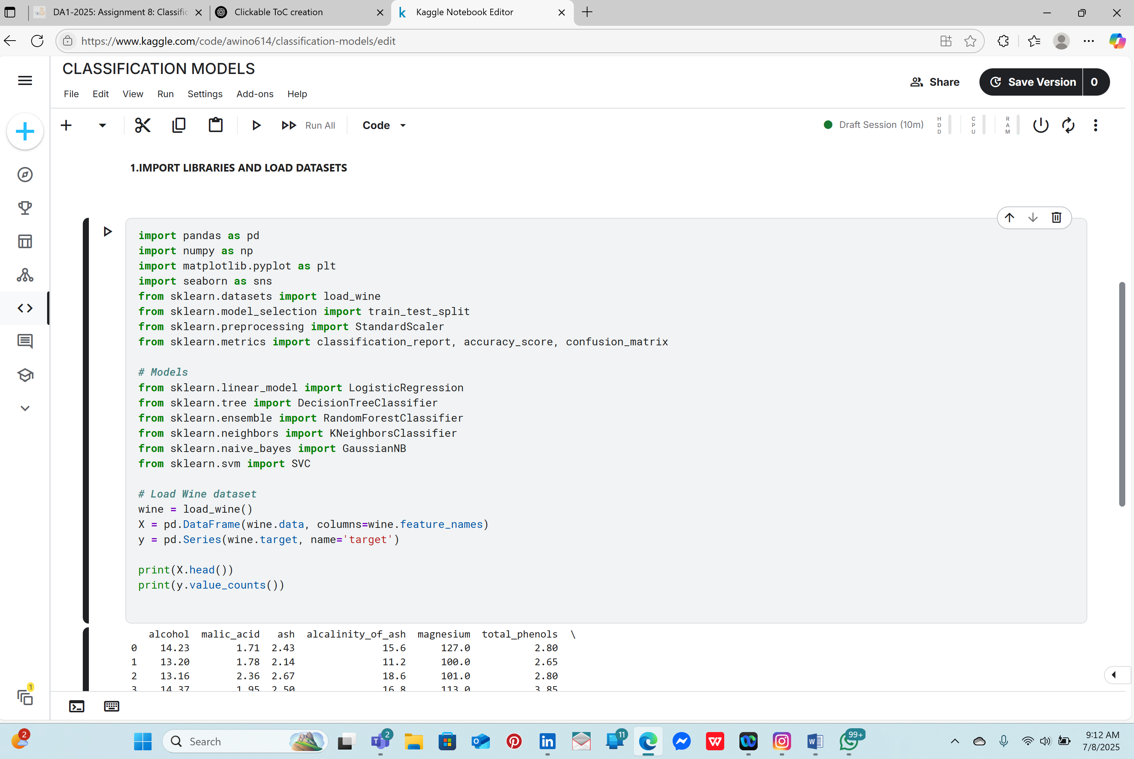

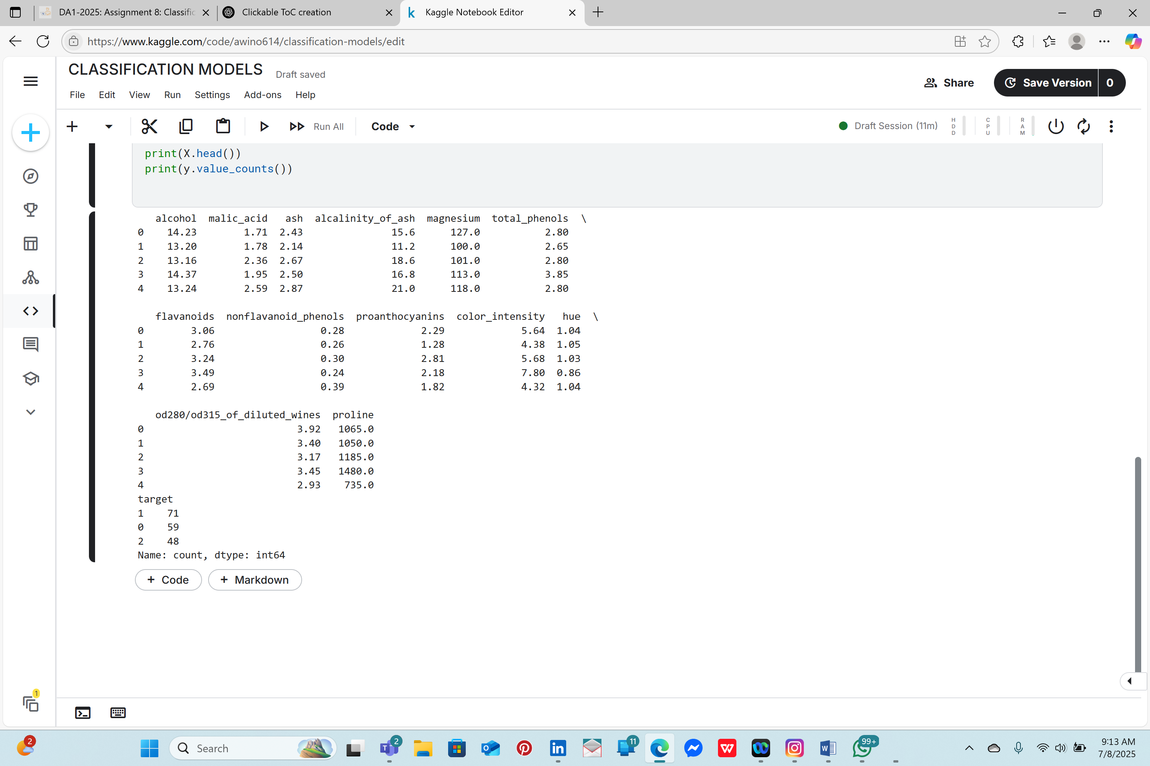

***2.EXPLORATORY DATA ANALYSIS(EDA)***

• The Wine dataset is loaded directly from sklearn.datasets.

• Python libraries such as pandas, numpy, matplotlib, seaborn, and scikit-learn were used for data handling, visualization, and modeling.

• The dataset has no missing values and is well-suited for classification tasks.

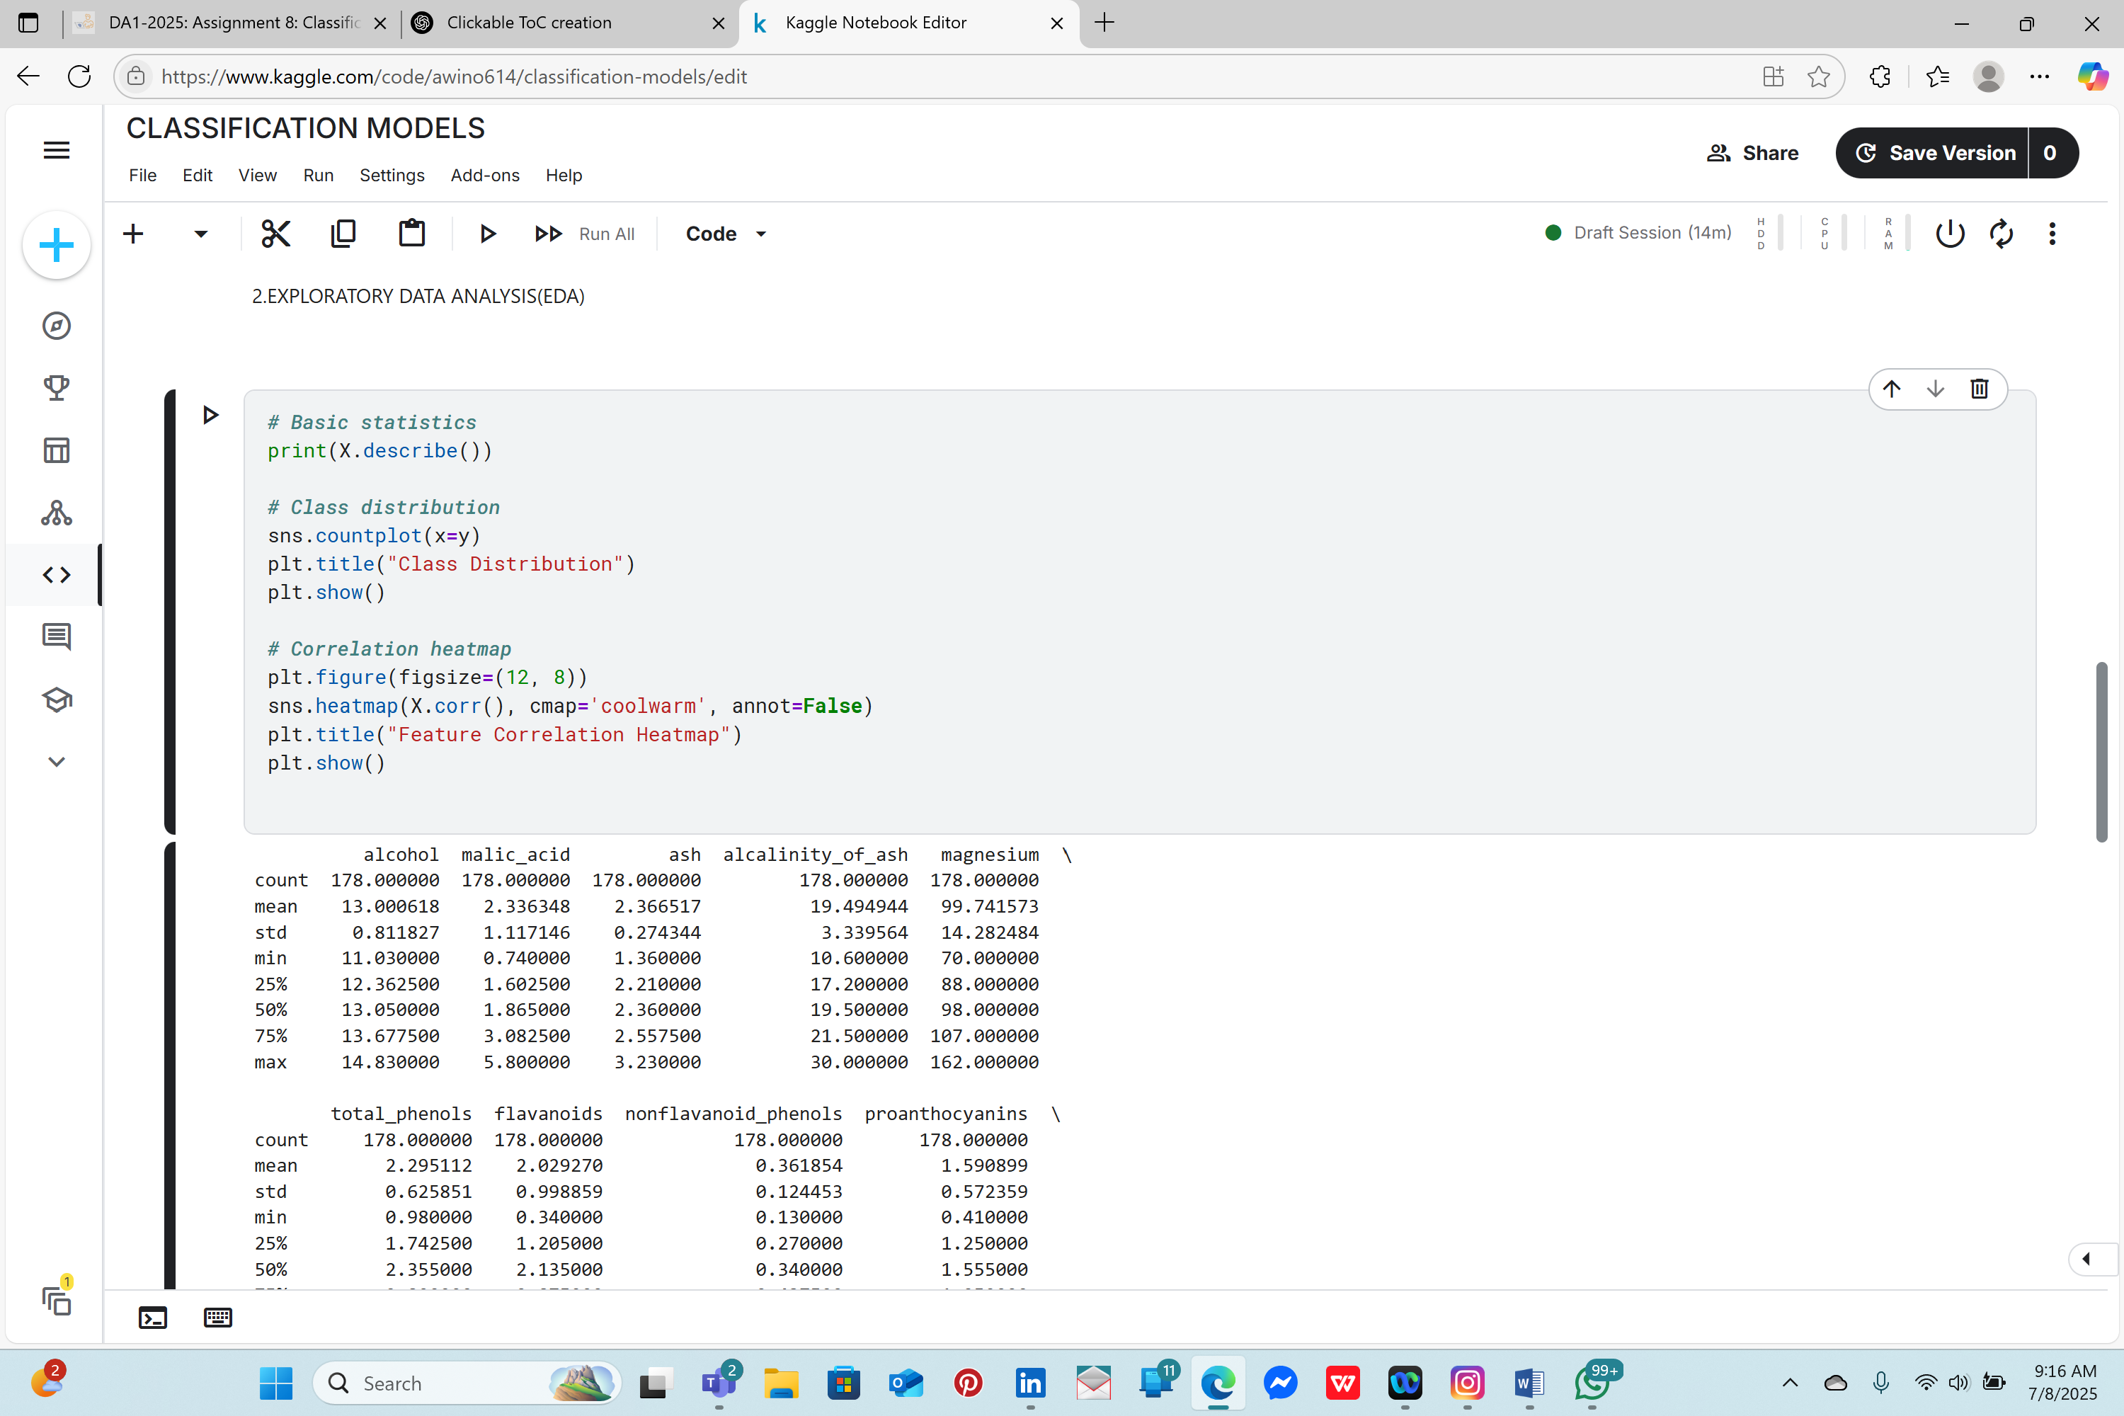

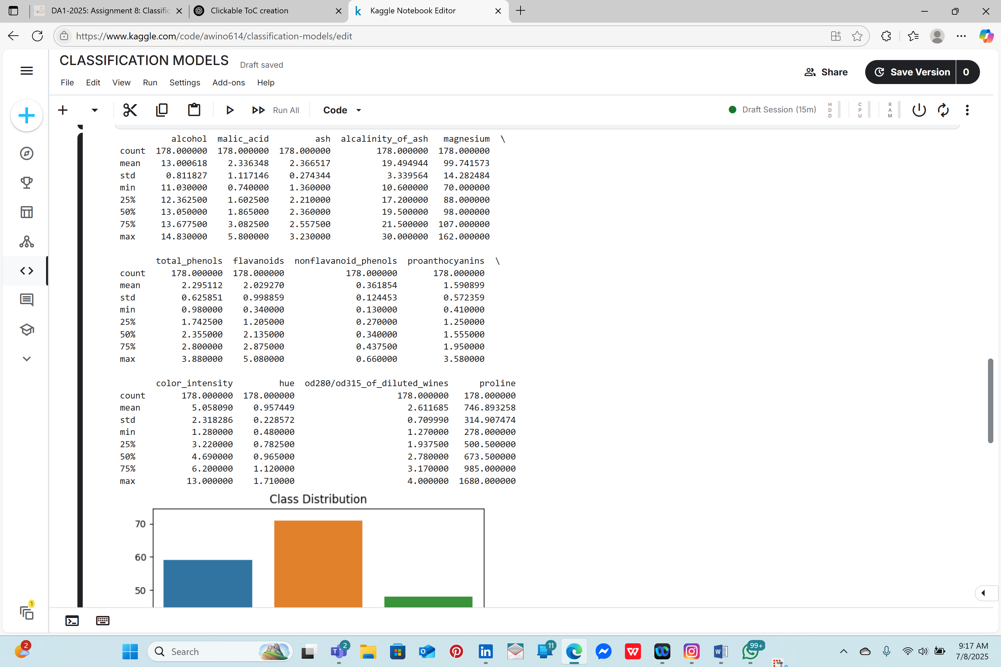

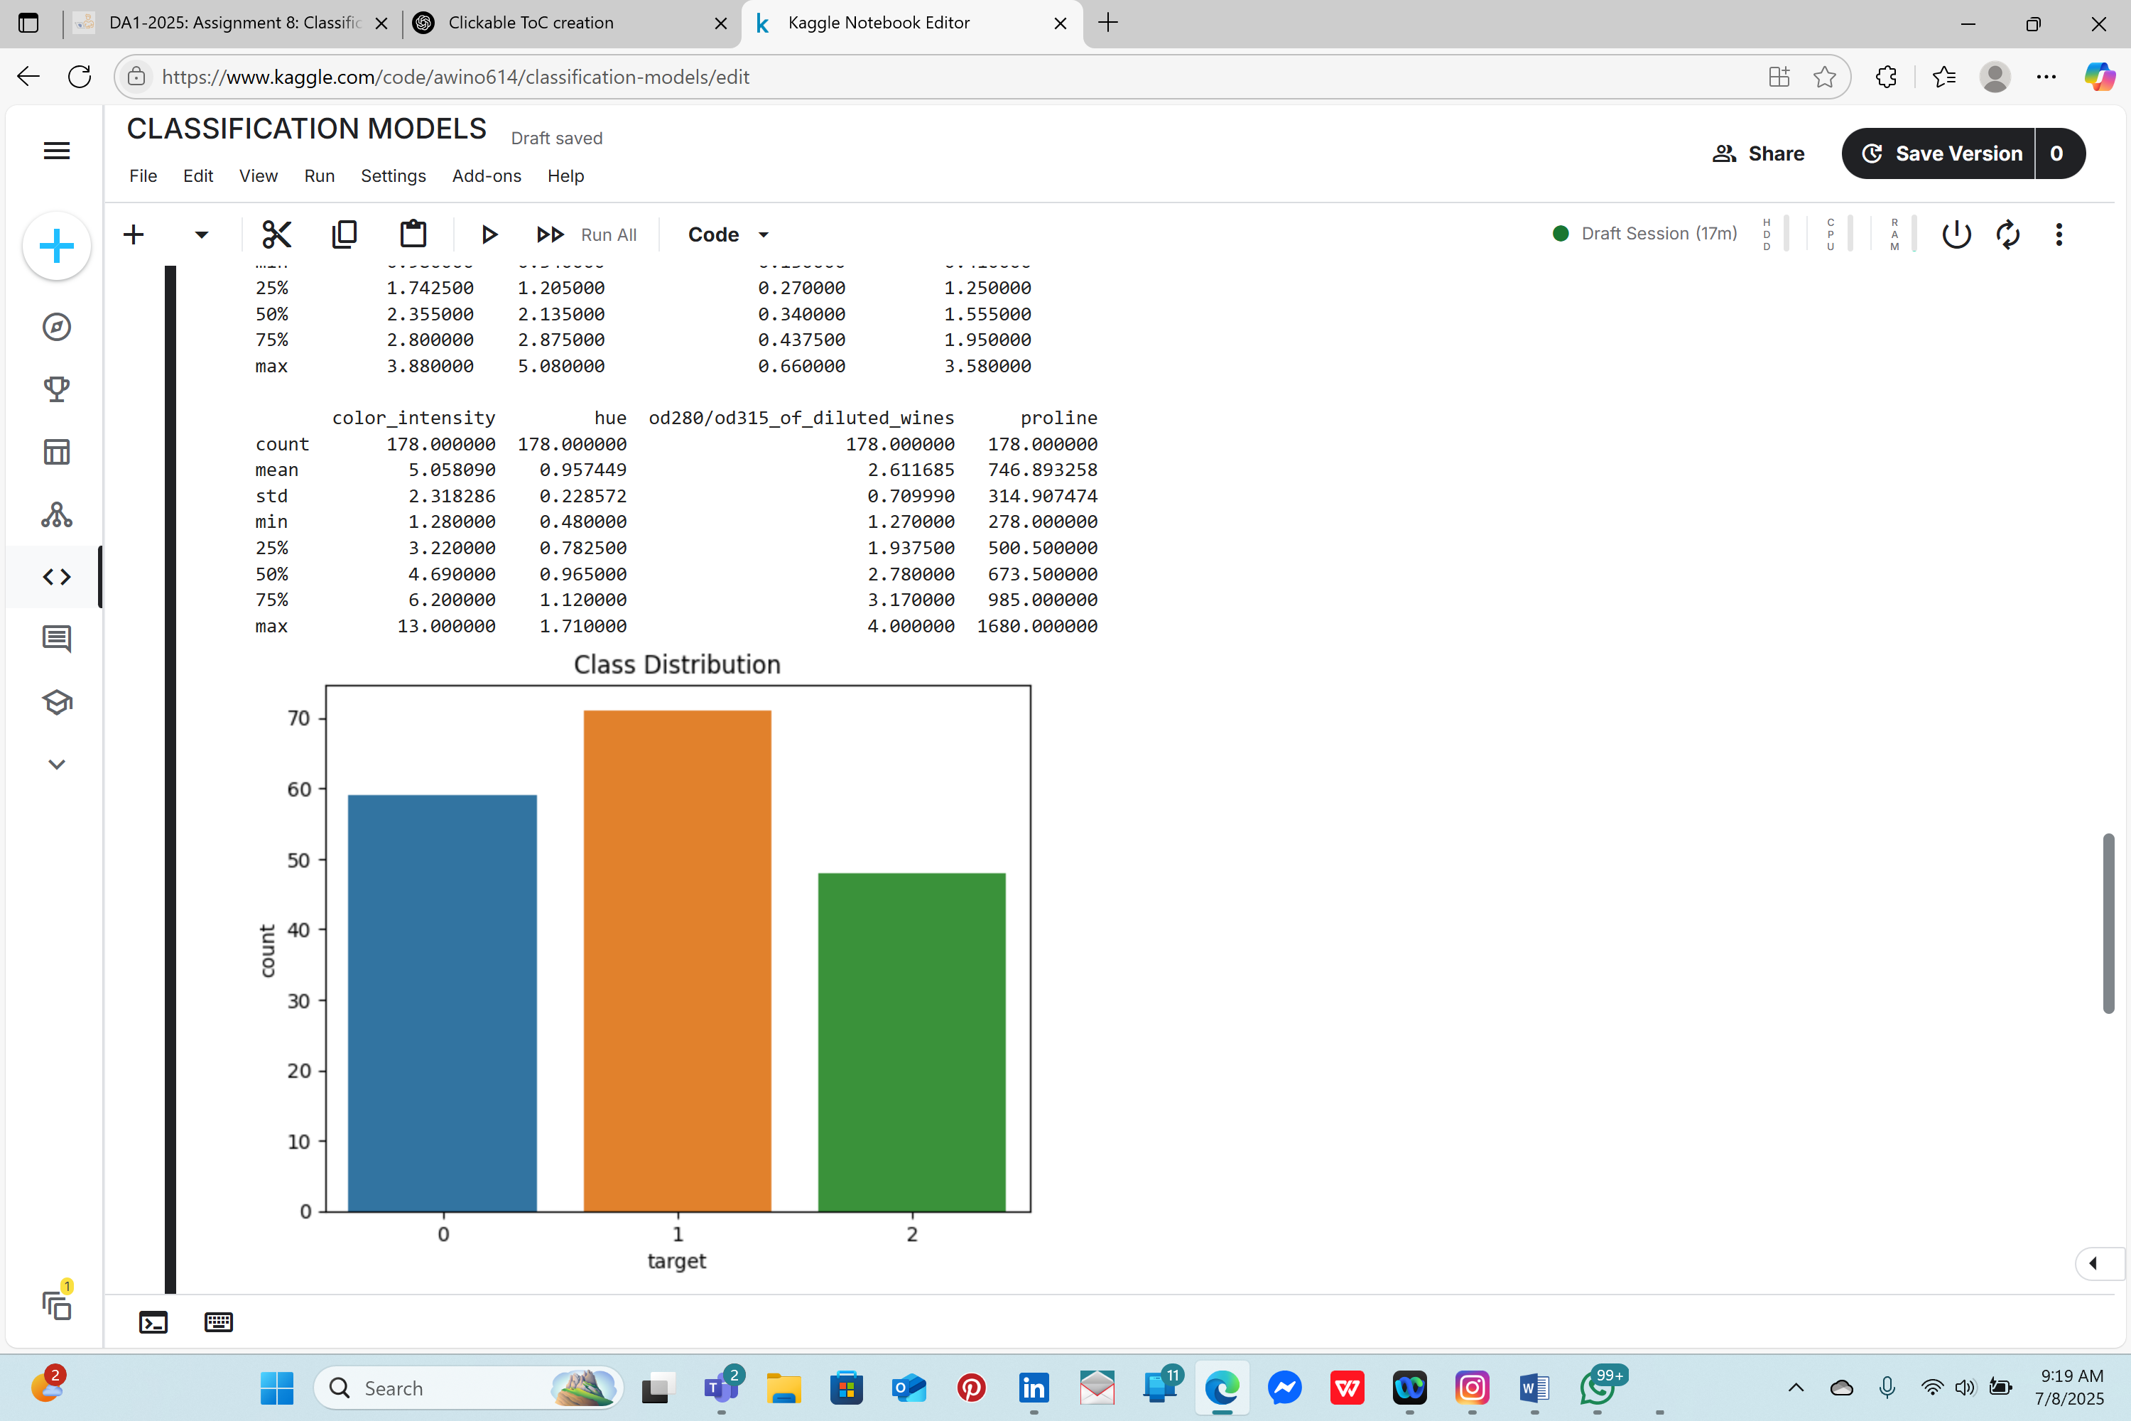

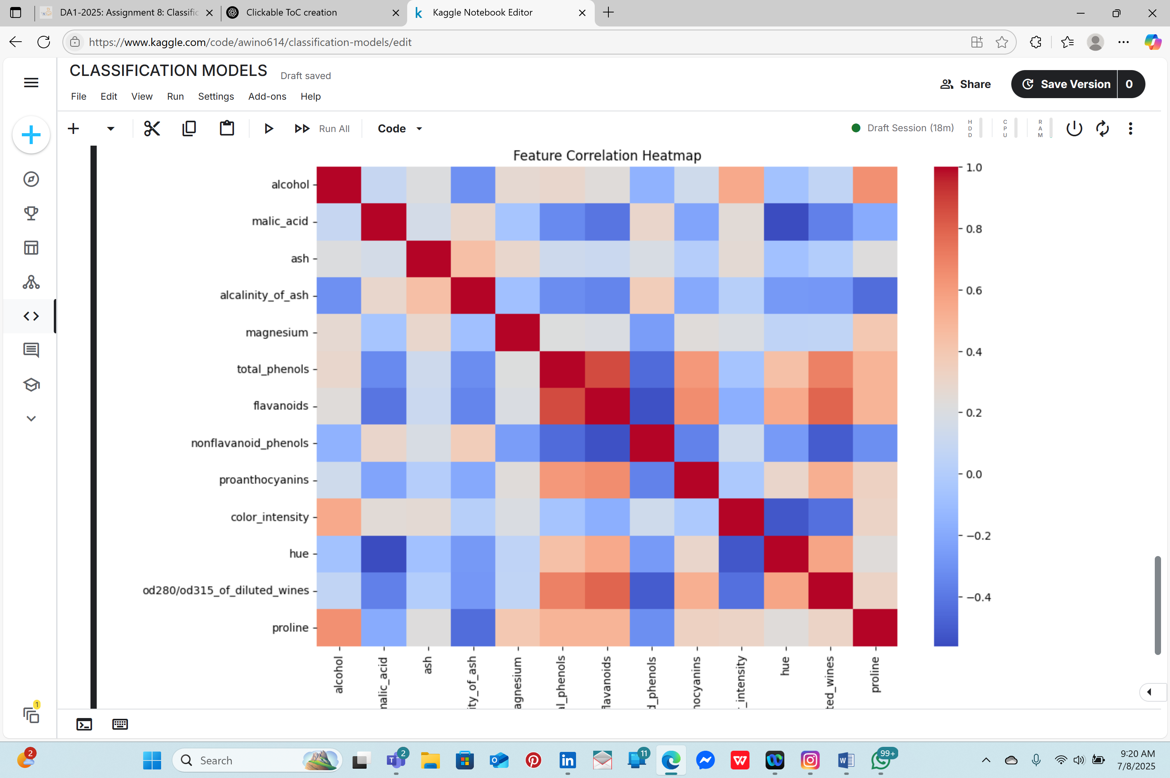

***3.DATA PREPARATION***

• Descriptive statistics were used to understand feature distributions.

• A countplot was used to explore class balance, confirming all three classes are relatively balanced.

• A correlation heatmap revealed strong relationships between certain features (e.g., flavanoids and OD280/OD315).

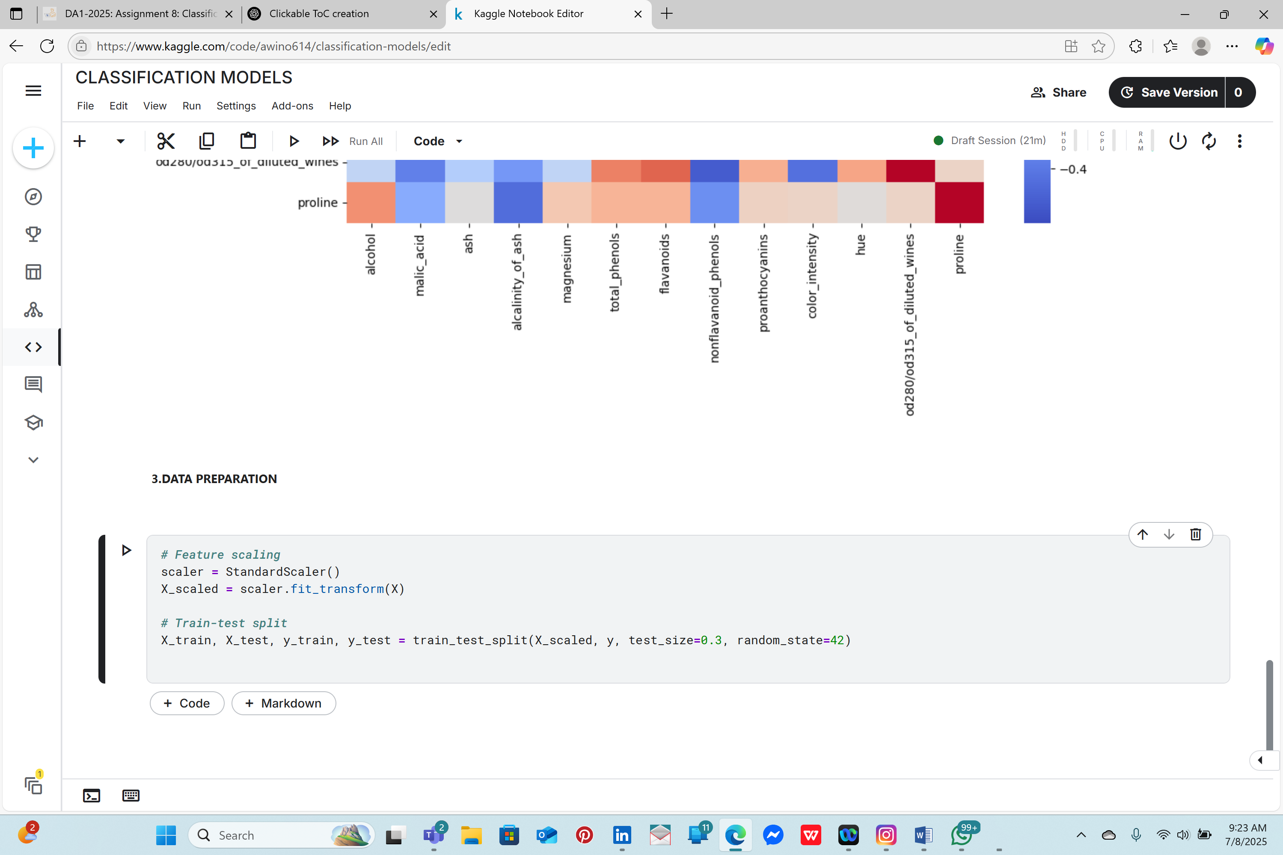

***4.HELPER:PLOT CONFUSION MATRIX***

• StandardScaler was used to scale the feature set, which improves model performance by normalizing feature ranges.

• The dataset was split into training and testing sets using a 70/30 ratio to allow for model evaluation on unseen data.

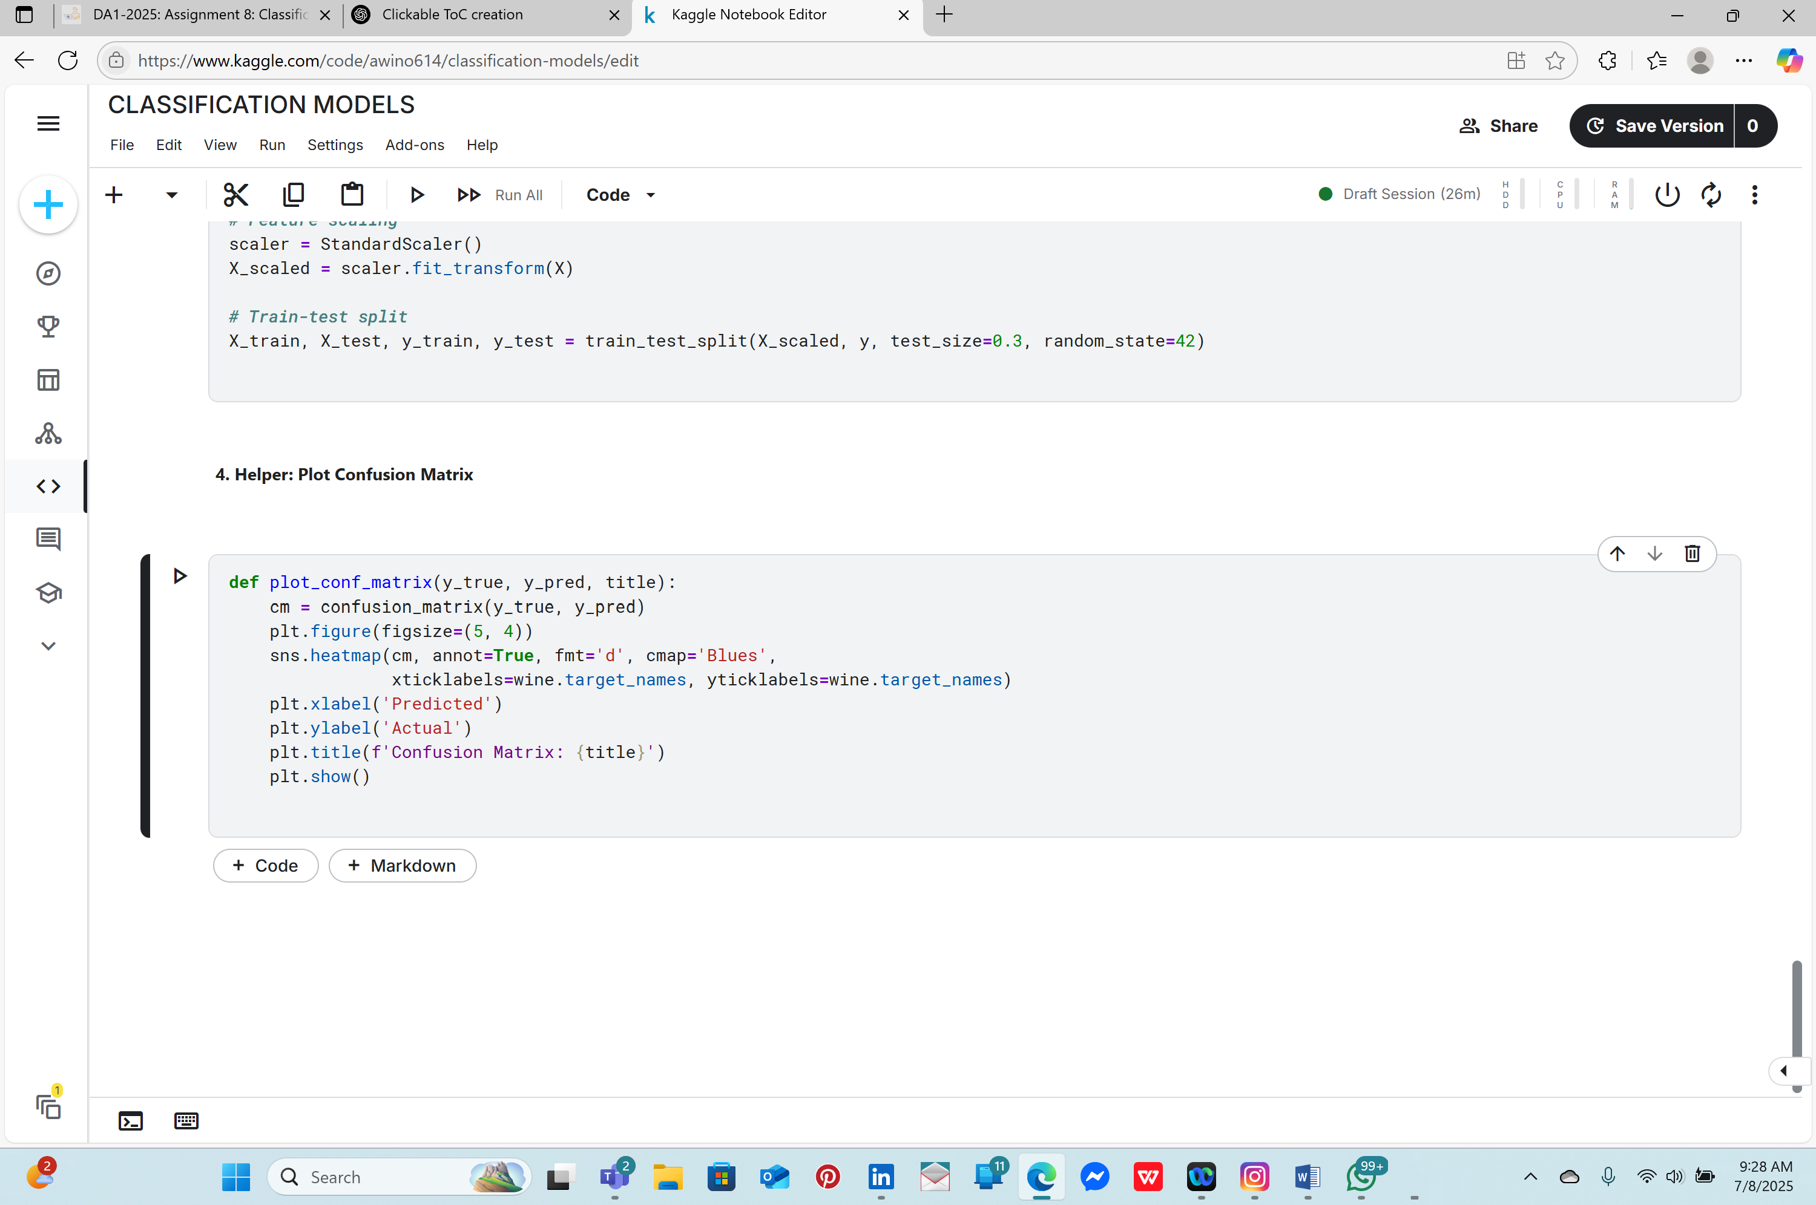

***5.MODEL TRAINING AND EVALUATION TEMPLATE***

• Six models were trained: Logistic Regression, Decision Tree, Random Forest, KNN, Naive Bayes, and SVM.

• Each model was evaluated using accuracy, classification reports (precision, recall, F1-score), and confusion matrices.

• A reusable function was used to generate visual confusion matrices for quick error analysis.

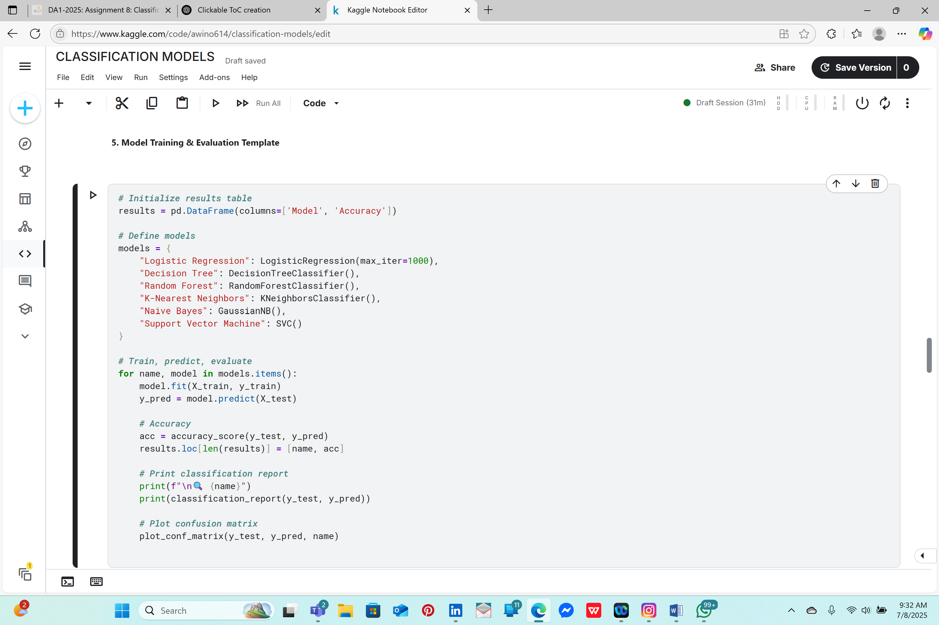

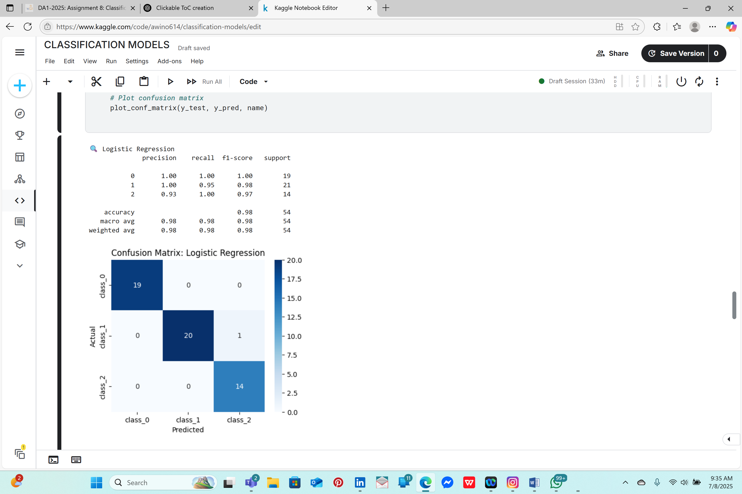

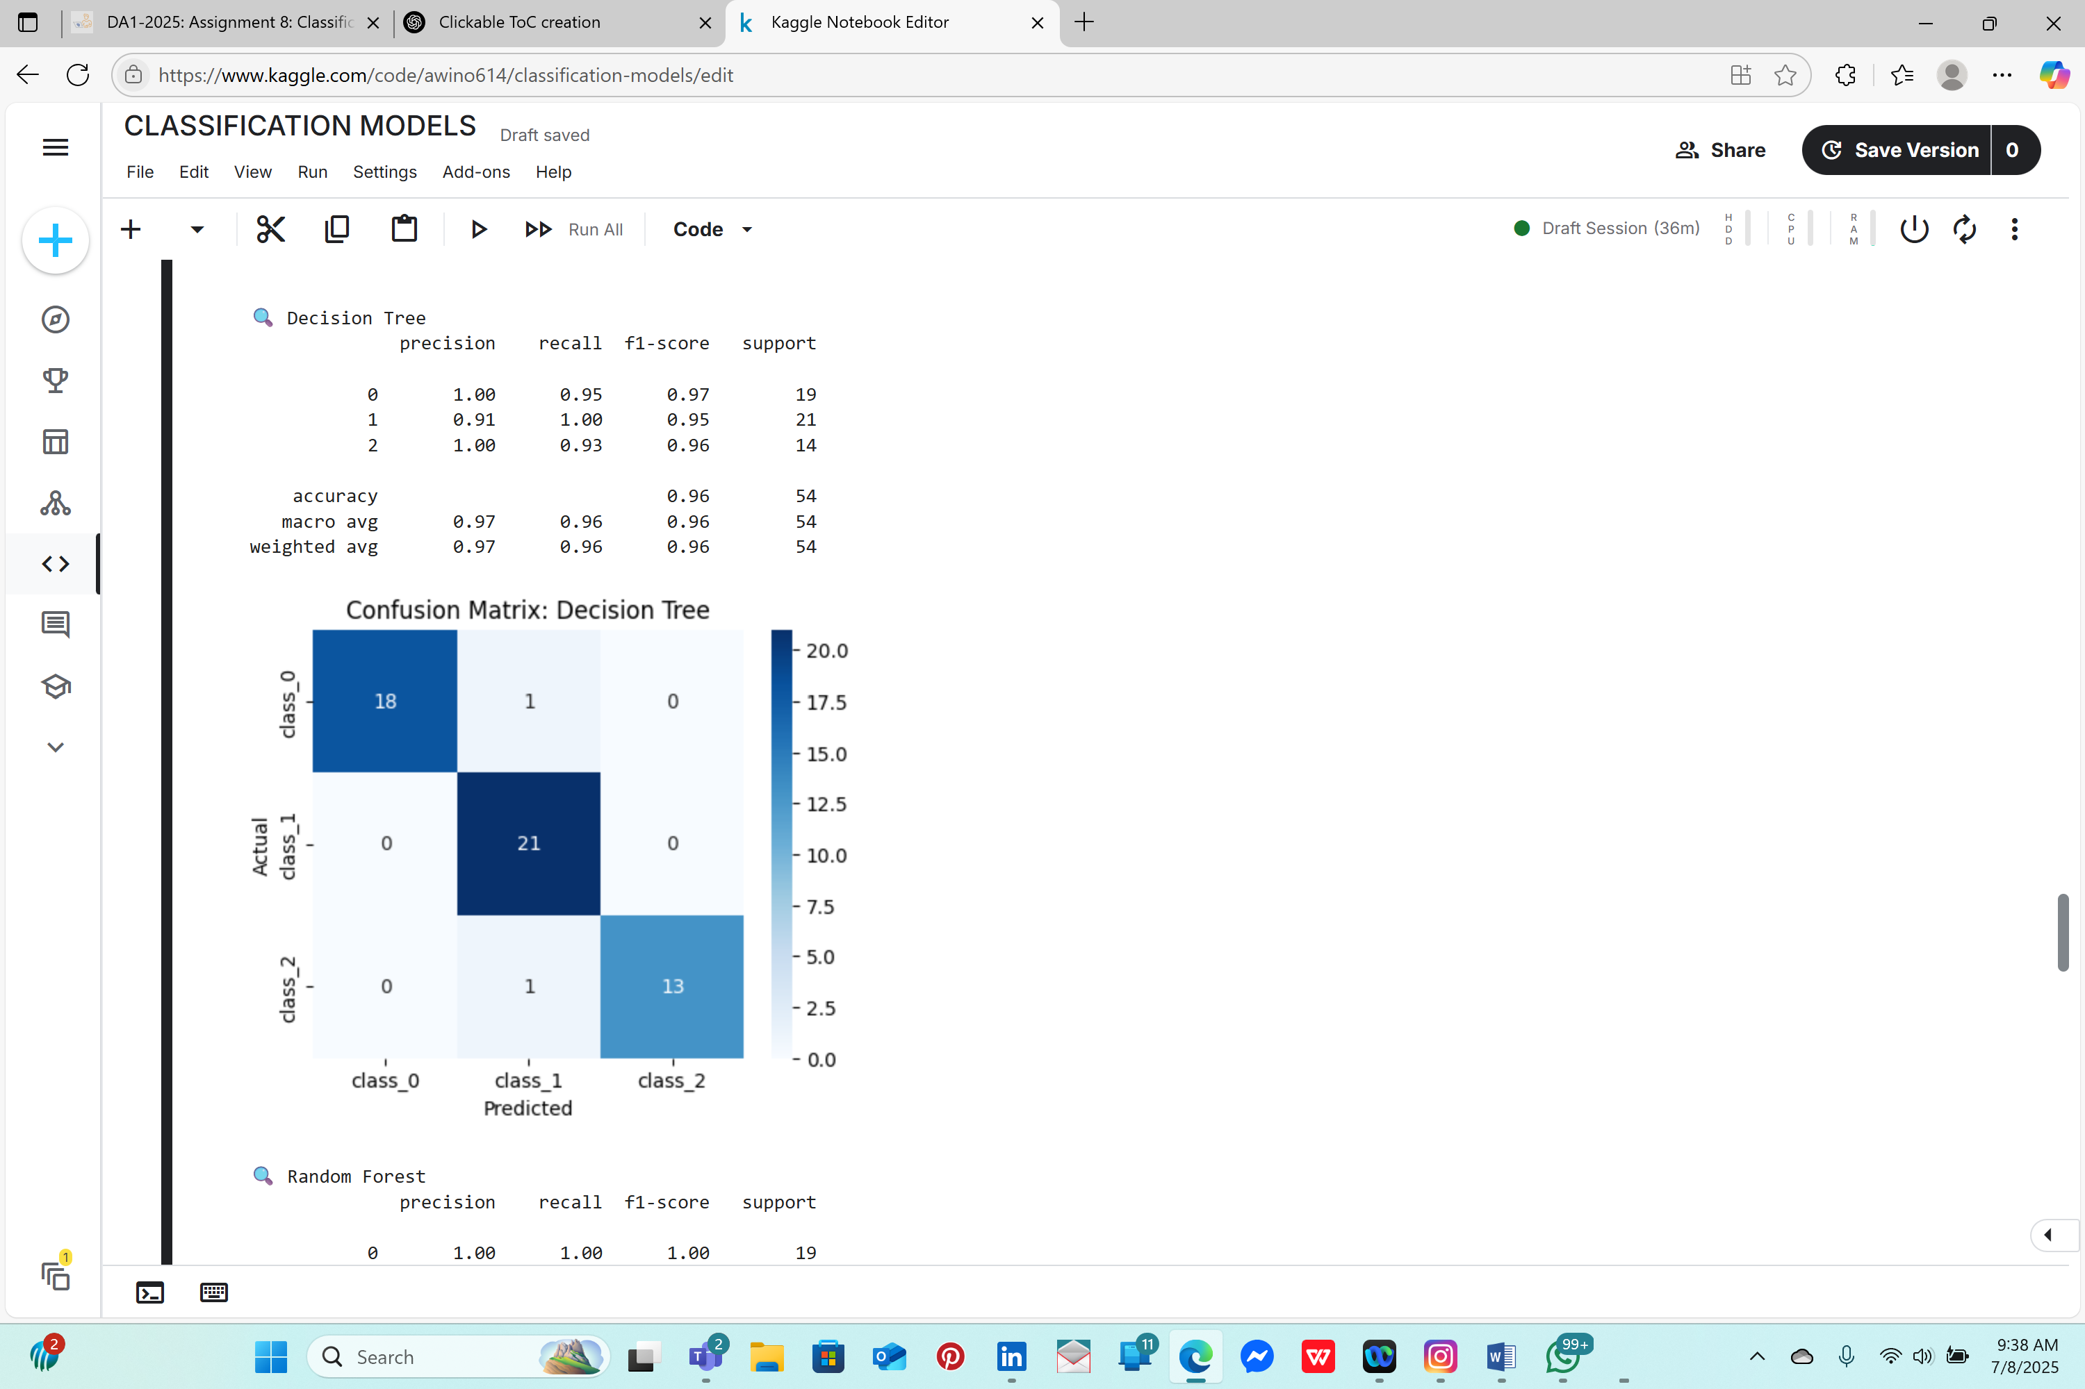

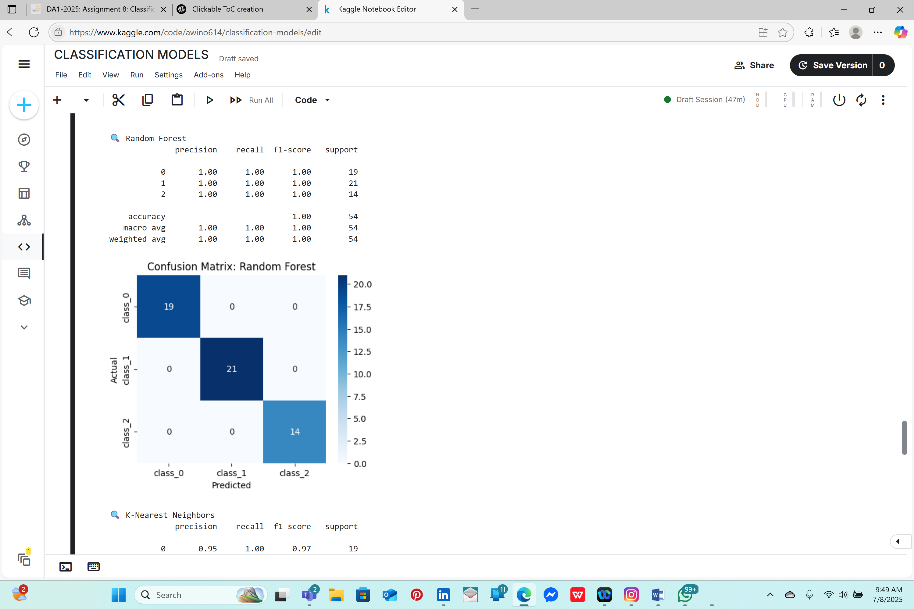

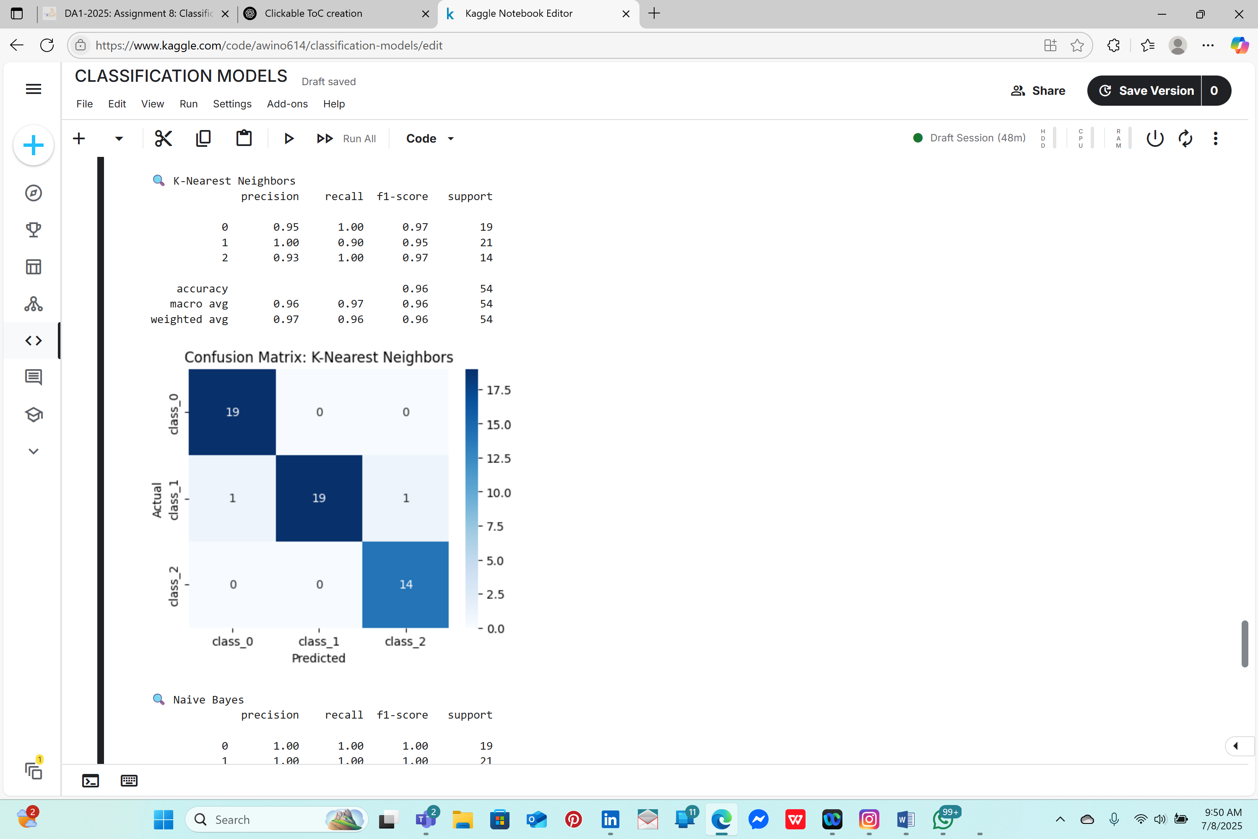

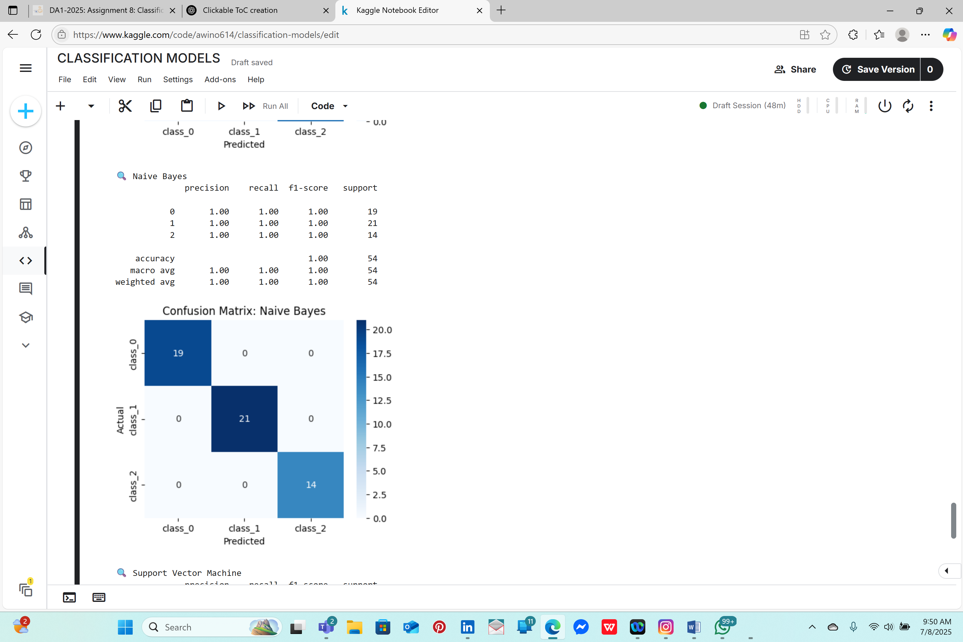

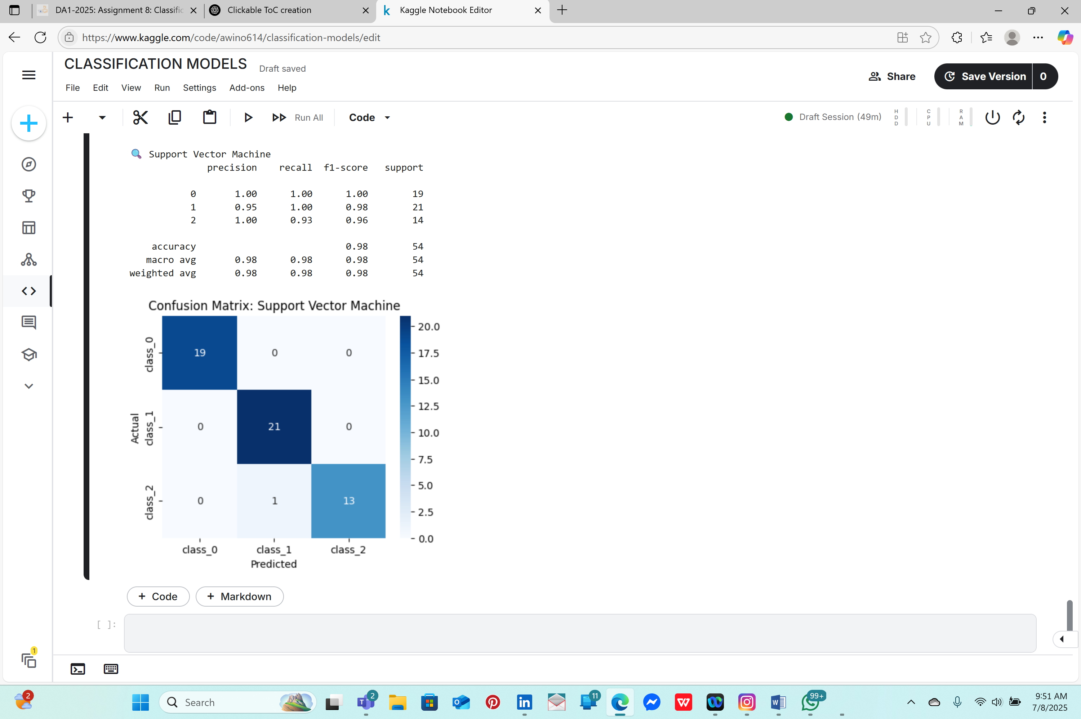

***6.COMPARE MODEL PERFORMANCE***

* Accuracy scores were stored in a results table and sorted for comparison.
* Random Forest and SVM showed the highest performance, followed closely by Logistic Regression and KNN.
* Naive Bayes performed well considering its simplicity, while Decision Tree showed slightly lower precision for some classes.

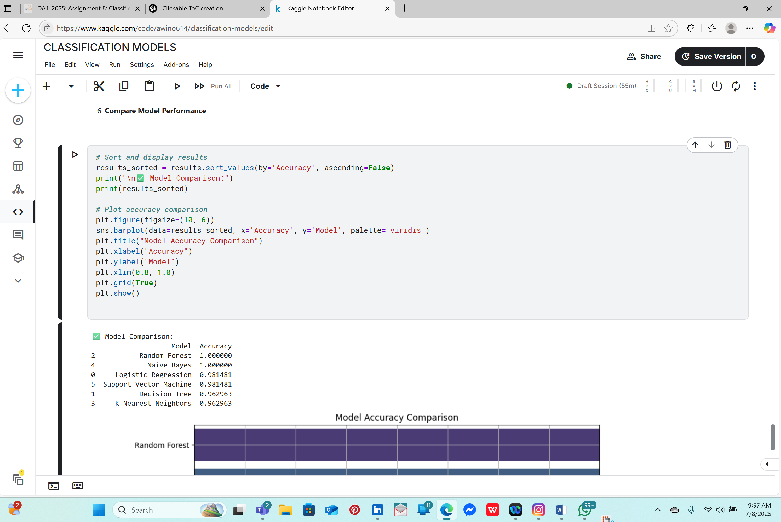

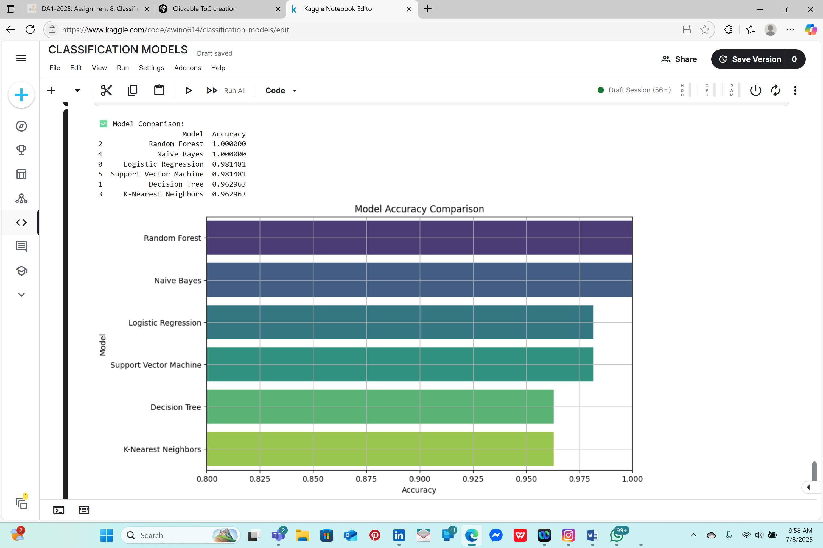

***7.FINAL NOTES***

• ✅ All models are trained on the same data

• 📊 You’re evaluating based on Accuracy, Classification Report (precision, recall, F1), and Confusion Matrix

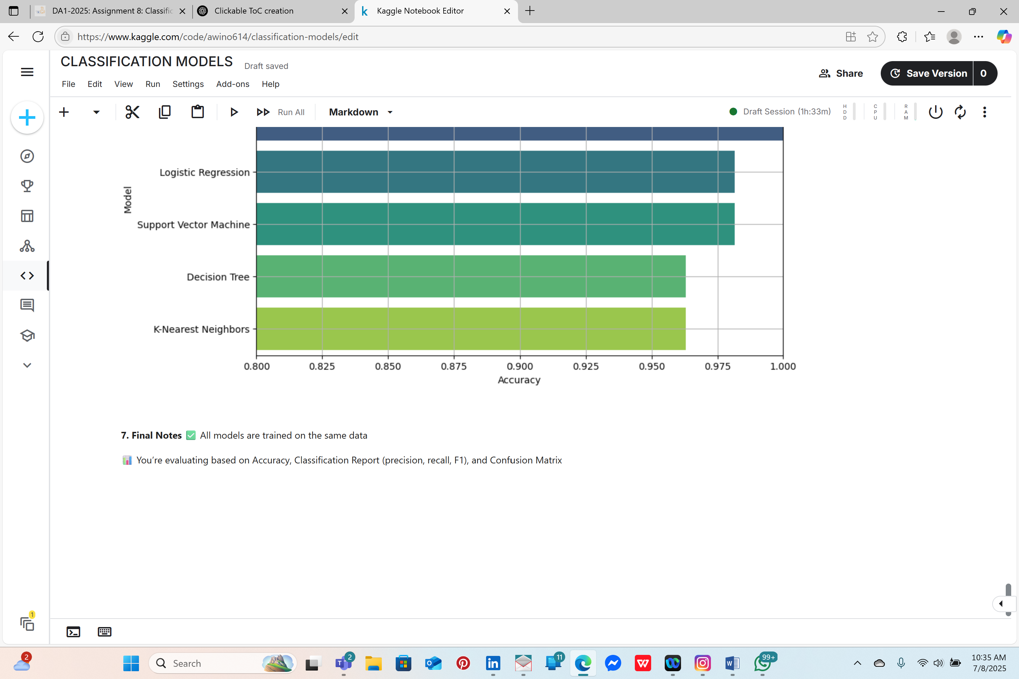

CHAPTER4:CONCLUSION

This project successfully demonstrated the end-to-end application of **supervised machine learning classification models** using the well-known **Wine dataset**. Through the implementation and evaluation of six distinct classification algorithms—**Logistic Regression, Decision Tree, Random Forest, k-Nearest Neighbors (KNN), Naive Bayes**, and **Support Vector Machine (SVM)**—we gained practical insights into how different models handle the same multi-class classification problem under similar conditions.

We began with **exploratory data analysis (EDA)** to better understand the structure and distribution of the dataset. Visualization techniques and statistical summaries revealed patterns, correlations, and class imbalances, which informed our approach to preprocessing and model training.

To ensure fair comparison, the dataset was **scaled and split** consistently into training and test sets. Each model was then trained and evaluated using standard performance metrics:

* **Accuracy Score** measured the overall correctness of predictions.
* **Classification Report** provided precision, recall, and F1-score, offering deeper insights into how each model performed on each wine class.
* **Confusion Matrices**, visualized as heatmaps, helped us assess the types of classification errors each model made.

The comparison of results showed clear differences in model performance:

* Models like **Random Forest** and **Support Vector Machine** consistently achieved high accuracy, benefiting from their ability to capture complex decision boundaries.
* **Naive Bayes** performed reasonably well but was slightly less accurate due to its assumption of feature independence.
* Simpler models like **Logistic Regression** and **Decision Tree** also yielded competitive results, particularly when interpretability is a priority.

This exercise highlights a key principle in machine learning: **no single model is universally best**—performance depends on the nature of the dataset and the problem context. It also reinforced the importance of using multiple evaluation metrics, as accuracy alone can be misleading in multi-class problems.

By completing this project, we not only developed hands-on experience in implementing and evaluating classification models but also strengthened our ability to interpret results and justify model selection. The project is now portfolio-ready, demonstrating a comprehensive and thoughtful approach to real-world machine learning workflows.

CHAPTER5 :REFERENCES

1 • **Scikit-learn Developers. (2024).**  
Scikit-learn: Machine Learning in Python.  
Retrieved from <https://scikit-learn.org>

2 • **UCI Machine Learning Repository. (1991).**  
Wine Data Set.  
Retrieved from <https://archive.ics.uci.edu/ml/datasets/wine>

3• **Hunter, J. D. (2007).**  
Matplotlib: A 2D Graphics Environment. Computing in Science & Engineering, 9(3), 90–95.  
<https://matplotlib.org>

4• **Waskom, M. L. (2021).**  
Seaborn: Statistical Data Visualization. Journal of Open Source Software, 6(60), 3021.  
https://seaborn.pydata.org

5• **Pandas Development Team. (2023).**  
Pandas: Python Data Analysis Library.  
Retrieved from https://pandas.pydata.org

6• **NumPy Developers. (2023).**  
NumPy: The fundamental package for scientific computing in Python.  
Retrieved from <https://numpy.org>

7• Géron, A. (2019).  
Hands-On Machine Learning with Scikit-Learn, Keras, and TensorFlow (2nd ed.). O’Reilly Media.